# Send a message

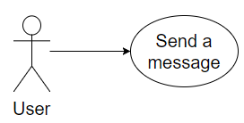

## Characteristic Information

|  |  |
| --- | --- |
| Superior business process: | Process-ID: refers to section 2.5.1 (business processes)> |
| Goal: | Is to communicate with friends in terms of sending him messages, files, images, links or videos |
| Precondition: | Needs to have a friend in his friend list |
| Postcondition: | The text chronic is saved  The user communicated with his friend |
| Involved User: | The User writs with his friend  The friend writs back |
| Triggering Event: | When the user sends a massage |

## GUI to call the use case

| Input field | Valid inputs |
| --- | --- |
| MessageTextBox | As in communicate with friends |

## GUIs for the standard use

| Step | User | Activity |
| --- | --- | --- |
| 1 | User | Start program |
| 2 | User | Choose image/select file/type in a message |
| 4 | User | Confirm |

## Scenarios for non-standard uses (bad cases or work around cases)

## GUIs for the non-standard uses

## Workflow

## Open Points